Name : Kirtesh Satish Admute
Roll No. : 258039
PRN : 250841220082
Module : DBT

show dbs
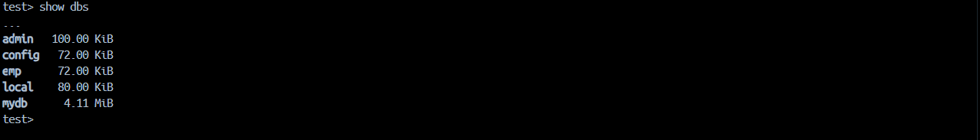

use mydb

show collections
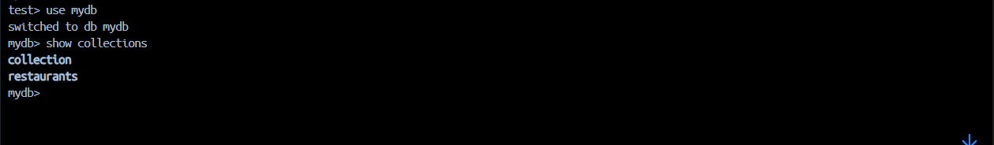

// rename collection restaurent to restaurants
db.restaurent.renameCollection('restaurants')

// 1. Write a MongoDB query to display all the documents in the collection restaurants
db.restaurants.find()
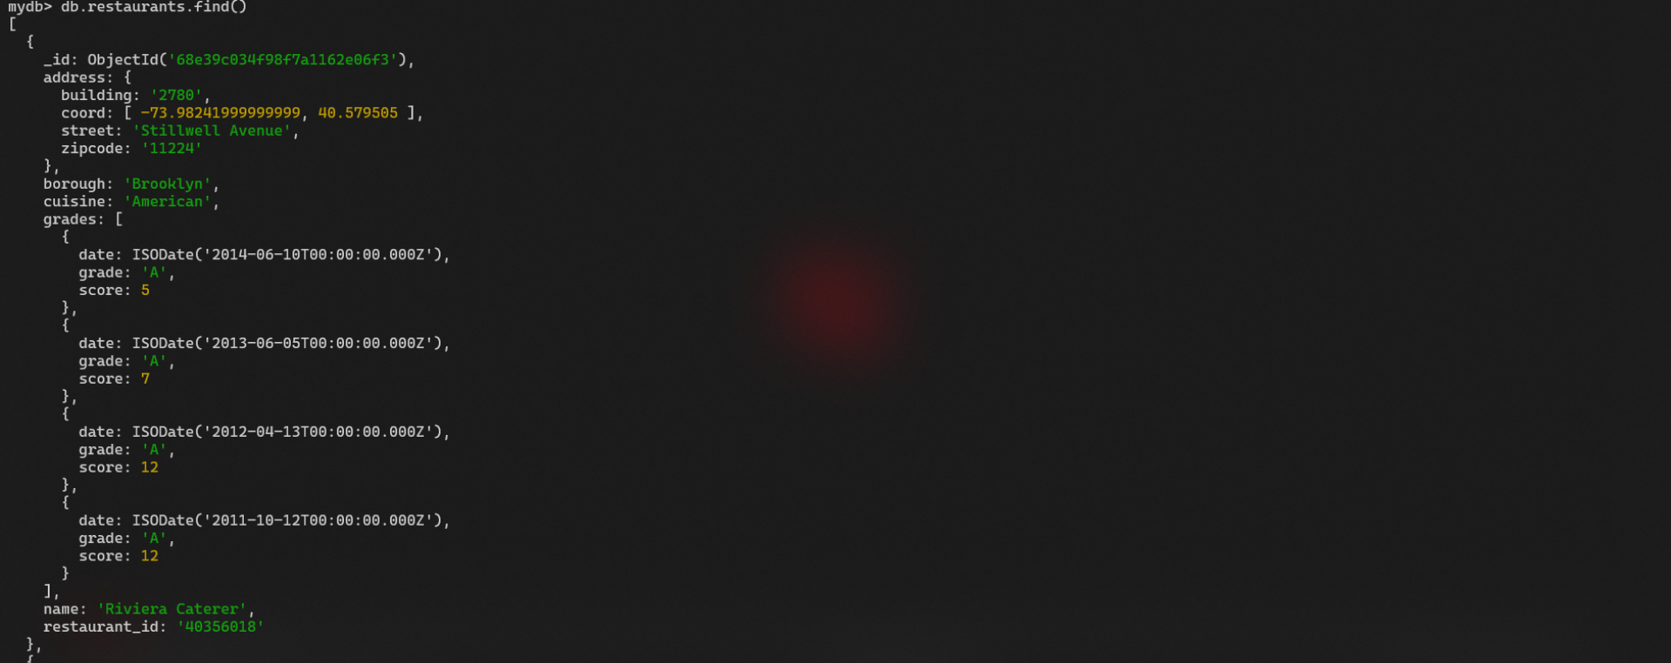

// 2. Write a MongoDB query to display the fields restaurant_id, name, borough and cuisine for all the documents in the collection restaurant.
db.restaurants.find({},
{restaurant_id:1, name:1, borough:1, cuisine:1}
)
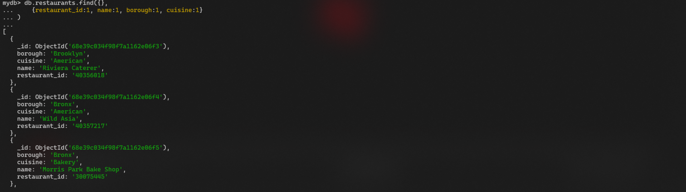
// 3. Write a MongoDB query to display the fields restaurant_id, name, borough and cuisine, but exclude the field _id for all the documents in the collection restaurant.
db.restaurants.find({},
{_id: 0, restaurant_id: 1, name: 1, borough: 1, cuisine: 1}
)
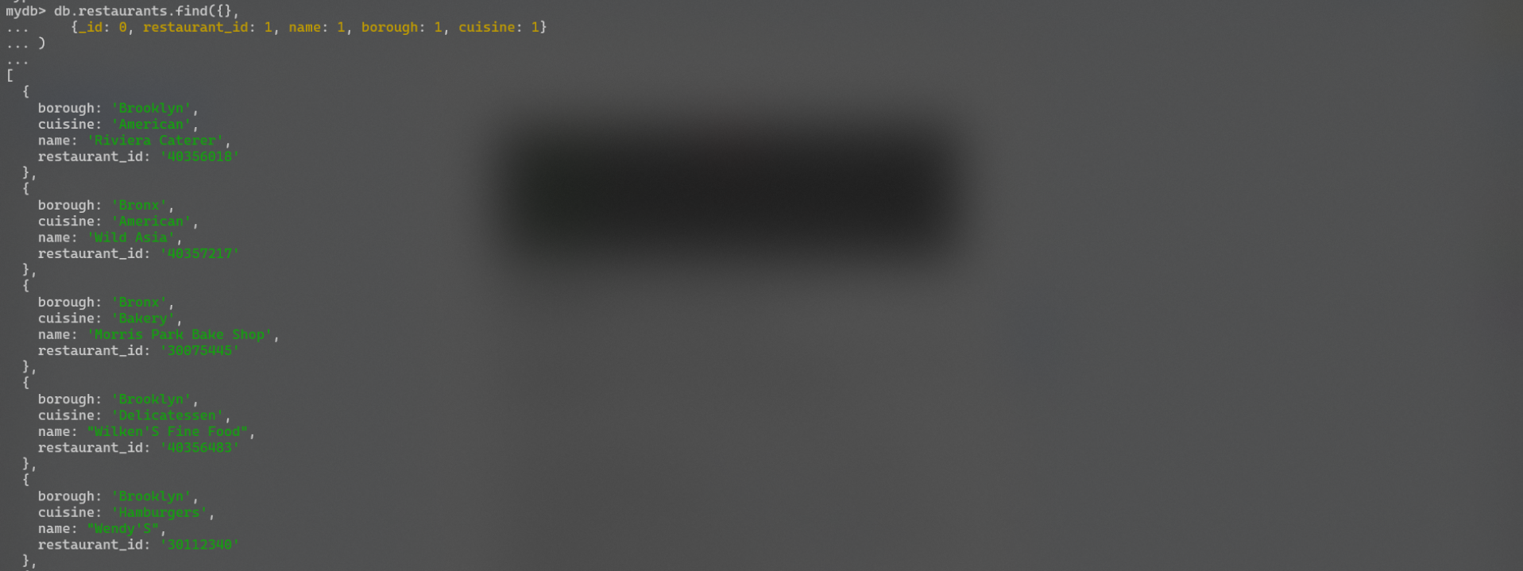
// 4. Write a MongoDB query to display the fields restaurant_id, name, borough and zip code, but exclude the field _id for all the documents in the collection restaurant.
db.restaurants.find({},
{_id: 0, restaurant_id: 1, name: 1, borough: 1, cuisine: 1, 'address.zipcode': 1}
)
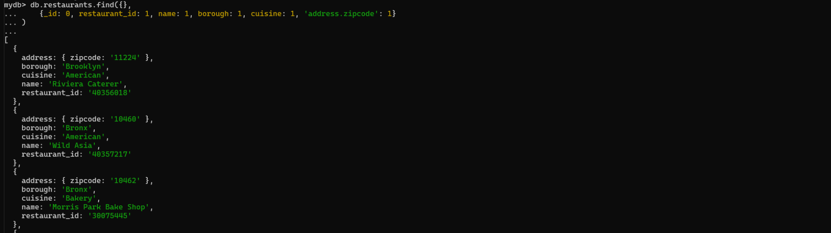
// 5. Write a MongoDB query to display all the restaurant which is in the borough Bronx
db.restaurants.find({borough: 'Bronx'})
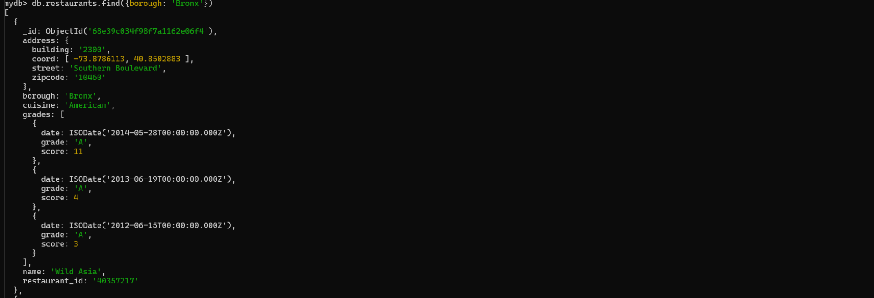
// 6. Write a MongoDB query to display the first 5 restaurant which is in the borough Bronx.
db.restaurants.find({borough: 'Bronx'}).limit(5)
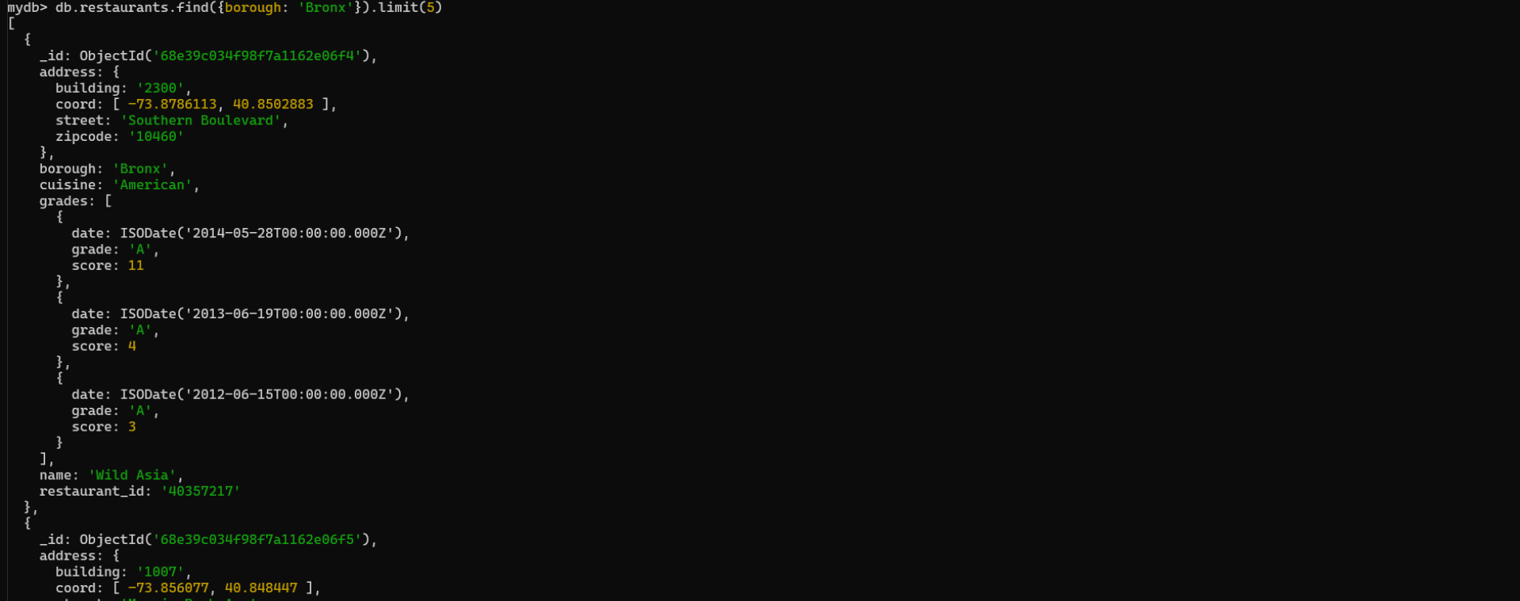
// 7. Write a MongoDB query to display the next 5 restaurants after skipping first 5 which are in the borough Bronx.
db.restaurants.find({borough: 'Bronx'}).limit(5).skip(5)
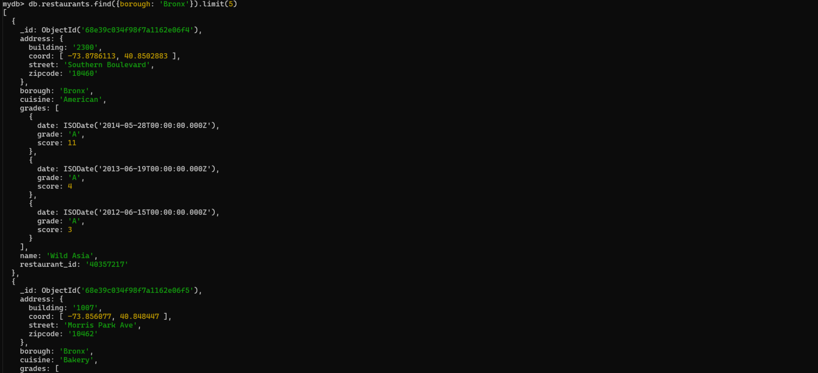
// 8. Write a MongoDB query to find the restaurants who achieved a score more than 90.
db.restaurants.find({'grades.score': {$gt: 90}})
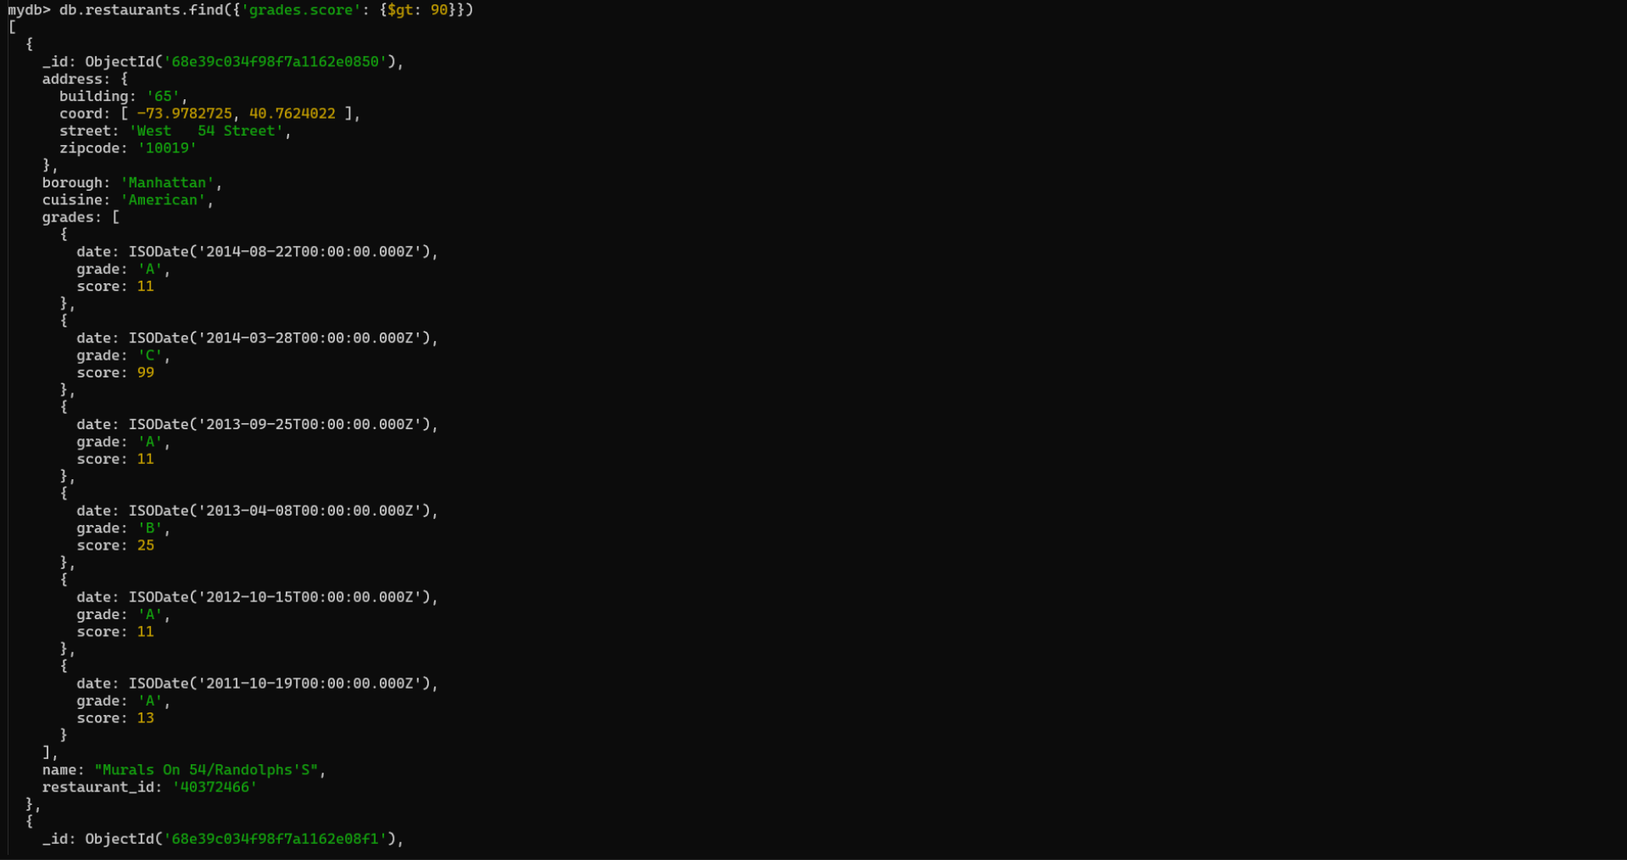
// 9. Write a MongoDB query to find the restaurants that achieved a score, more than 80 but less than 100.
db.restaurants.find({'grades.score': {$gt: 90, $lt: 100}})
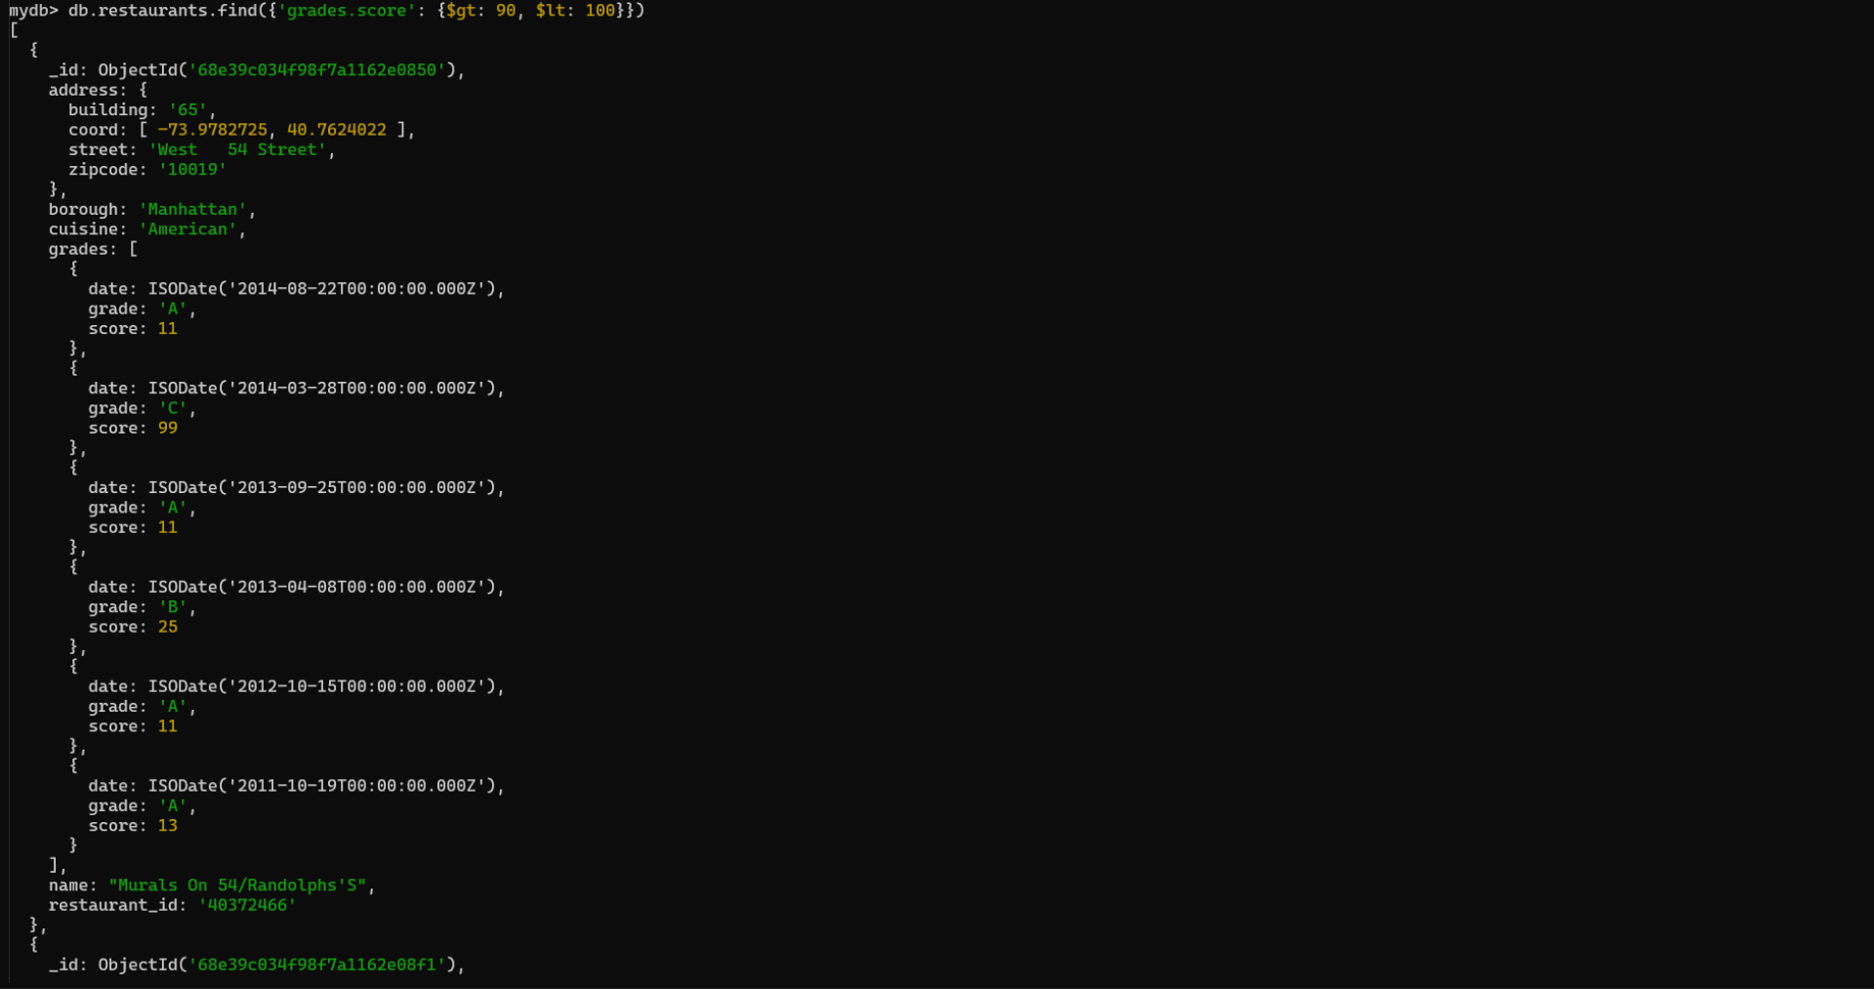
// 10. Write a MongoDB query to find the restaurants which locate in latitude value less than -95.754168.
db.restaurants.find({'address.coord.0': {$lt: -95.754168}})
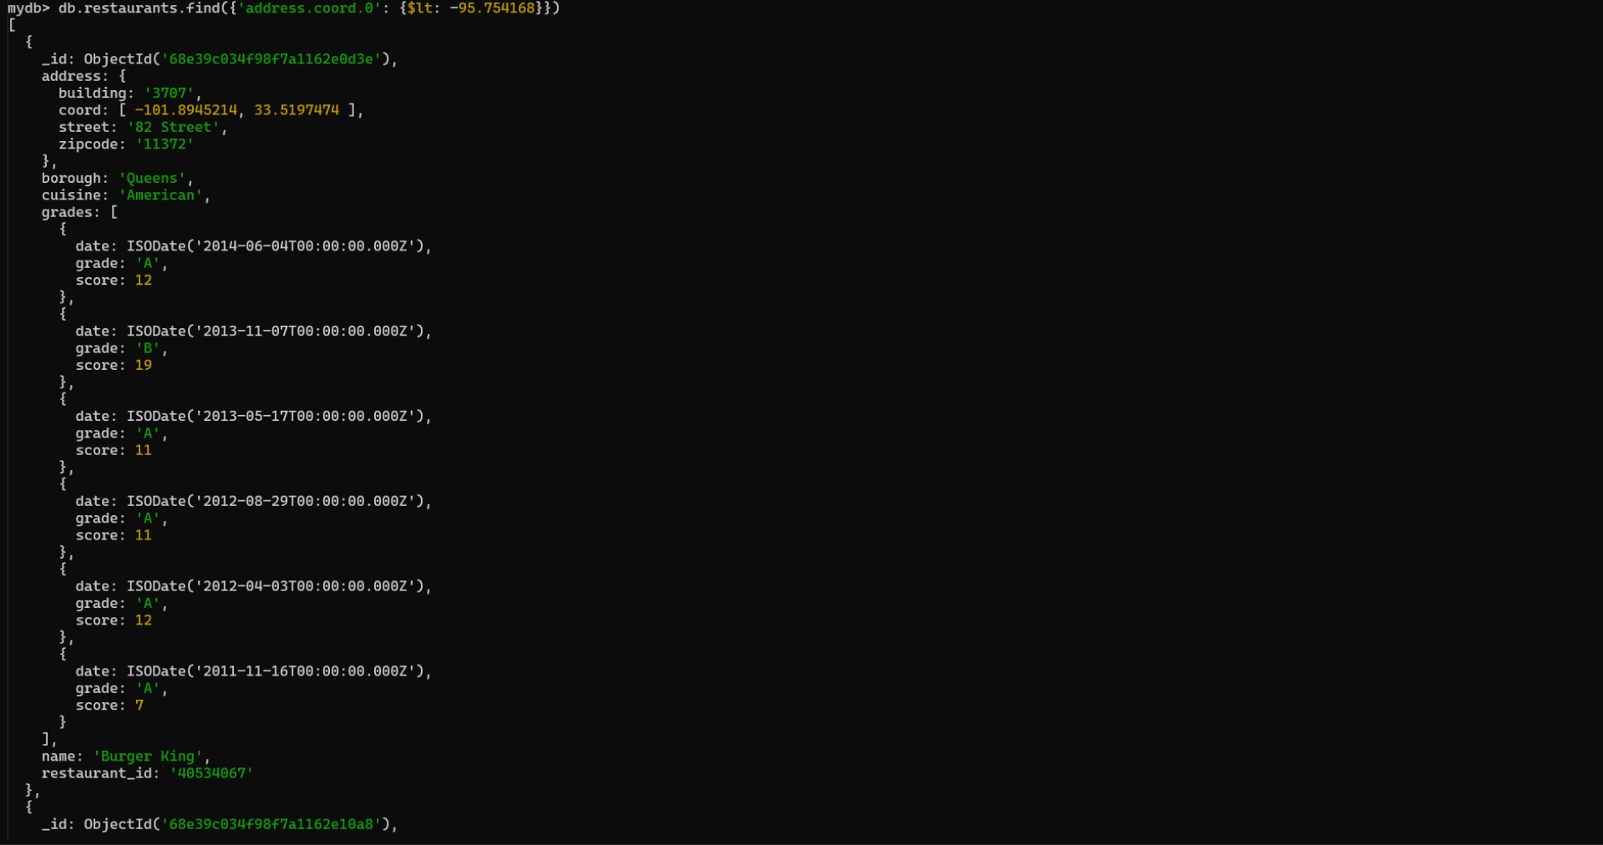
// 11. Write a MongoDB query to find the restaurants that do not prepare any cuisine of 'American' and their grade score more than 70 and latitude less than -65.754168.
// db.restaurants.find({{cuisine: 'American'},{'grades.score': $gt: 70}, {'address.coord.0': {$lt:-65.754168}}})
db.restaurants.find({
cuisine : {$nin :['American']},
'grades.score':{$gt:70},
'address.coord.0':{$lt:-65.754168}
})
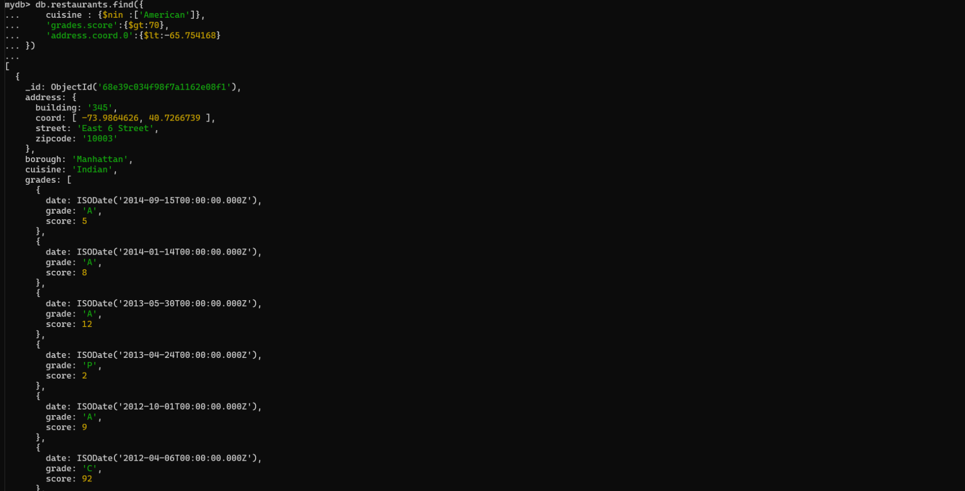
// 12. Write a MongoDB query to find the restaurants which do not prepare any cuisine of 'American' and achieved a score more than 70 and located in the longitude less than -65.754168.
db.restaurants.find({
cuisine : {$nin :['American']},
'grades.score':{$gt:70},
'address.coord.1':{$lt:-65.754168}
})
// 13. Write a MongoDB query to find the restaurants which do not prepare any cuisine of 'American' and achieved a grade point 'A' not belongs to the borough Brooklyn. The document must be displayed according to the cuisine in descending order.
db.restaurants.find({
cusinie: {
$nin: ['American']}, 'grades.grade' : 'A', 'borough':
{$nin: ['Brooklyn']}}).sort({
cuisine: -1})
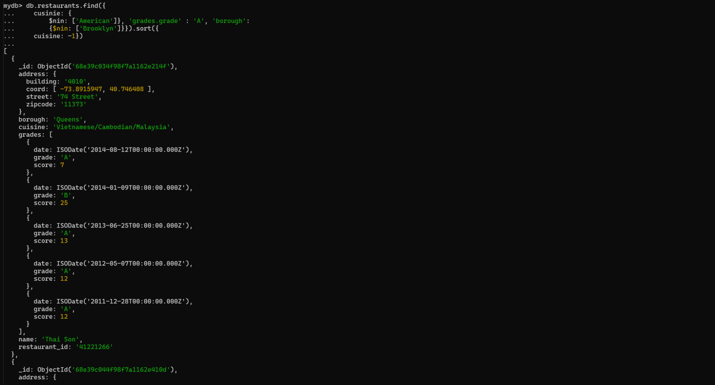
// 14. Write a MongoDB query to find the restaurant Id, name, borough and cuisine for those restaurants which contain 'Wil' as first three letters for its name.
db.restaurants.find(
{ name: { $regex: '^Wil', $options: 'i' } },
{ restaurant_id: 1, name: 1, borough: 1, cuisine: 1, _id: 0 }
)
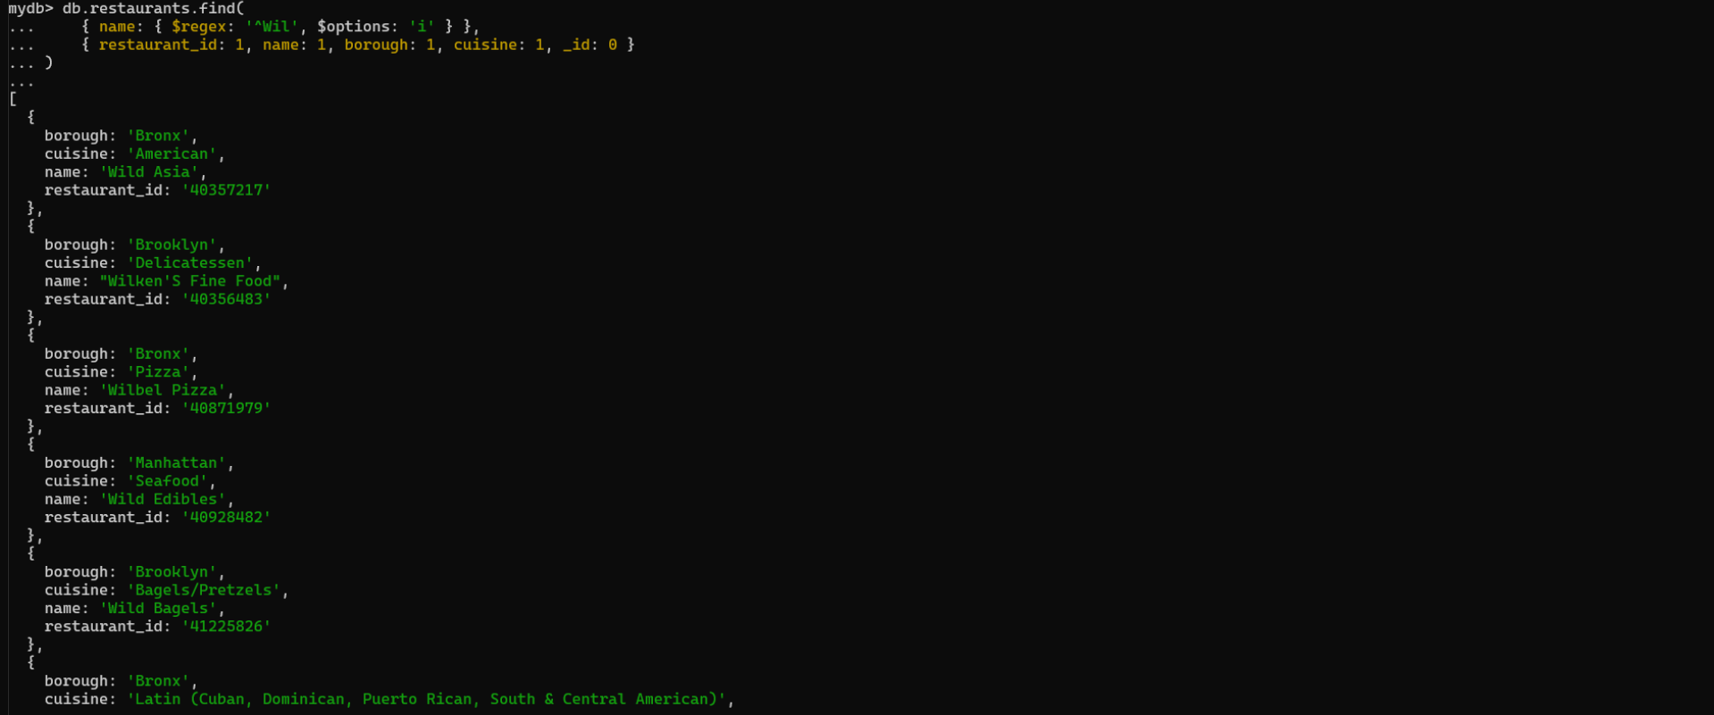
// 15. Write a MongoDB query to find the restaurant Id, name, borough and cuisine for those restaurants which contain 'ces' as last three letters for its name.
db.restaurants.find(
{name: { $regex: 'ces$'}},
{ restaurant_id: 1, name: 1, borough: 1, cuisine: 1, _id: 0 }
)
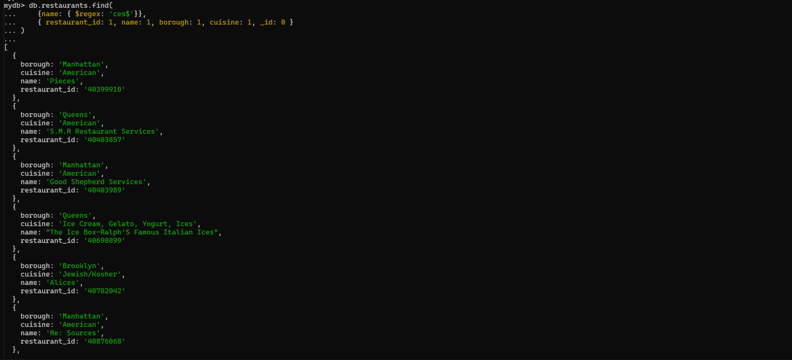
// 16. Write a MongoDB query to find the restaurant Id, name, borough and cuisine for those restaurants which contain 'Reg' as three letters somewhere in its name.
db.restaurants.find(
{name: { $regex: 'Reg'}},
{ restaurant_id: 1, name: 1, borough: 1, cuisine: 1, _id: 0 }
)
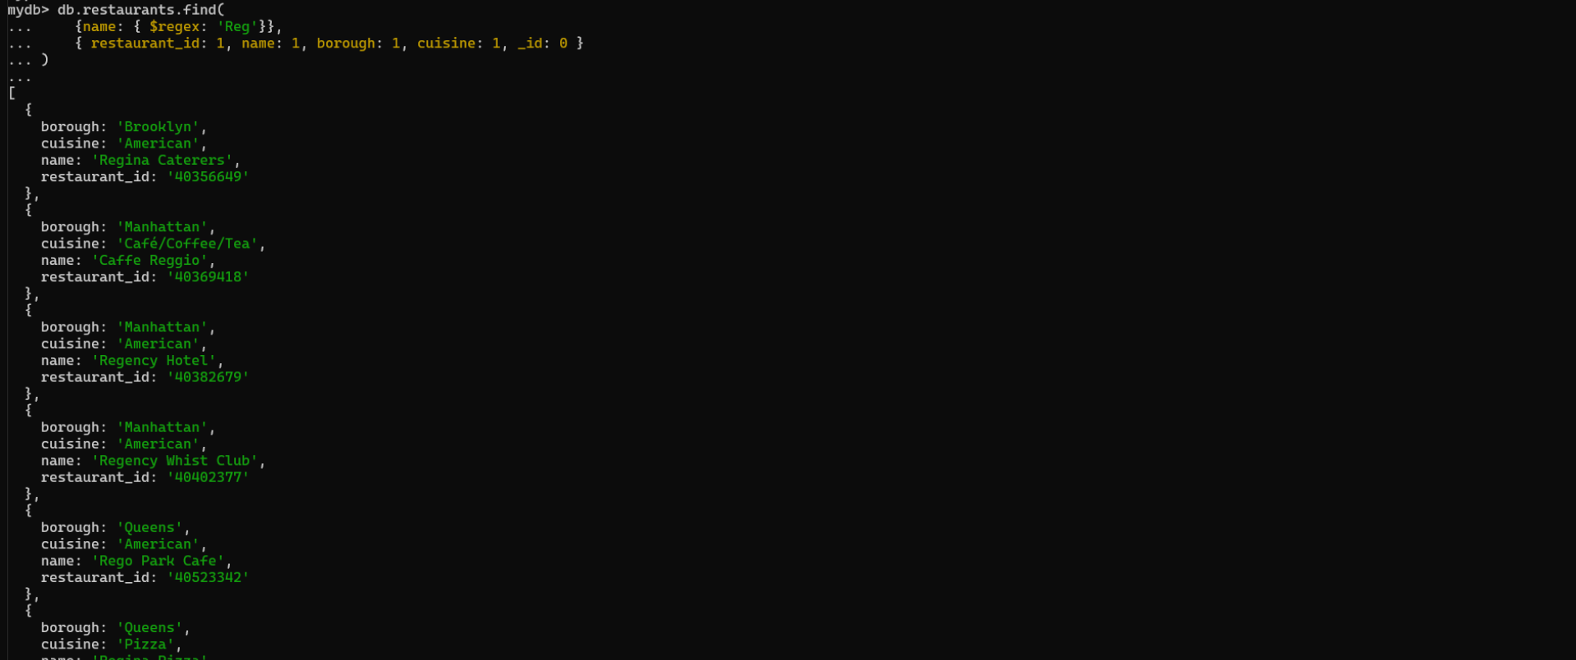
// 17. Write a MongoDB query to find the restaurants which belong to the borough Bronx and prepared either American or Chinese dish.
db.restaurants.find({ borough: 'Bronx', cuisine: { $in: ['American', 'Chinese'] } })
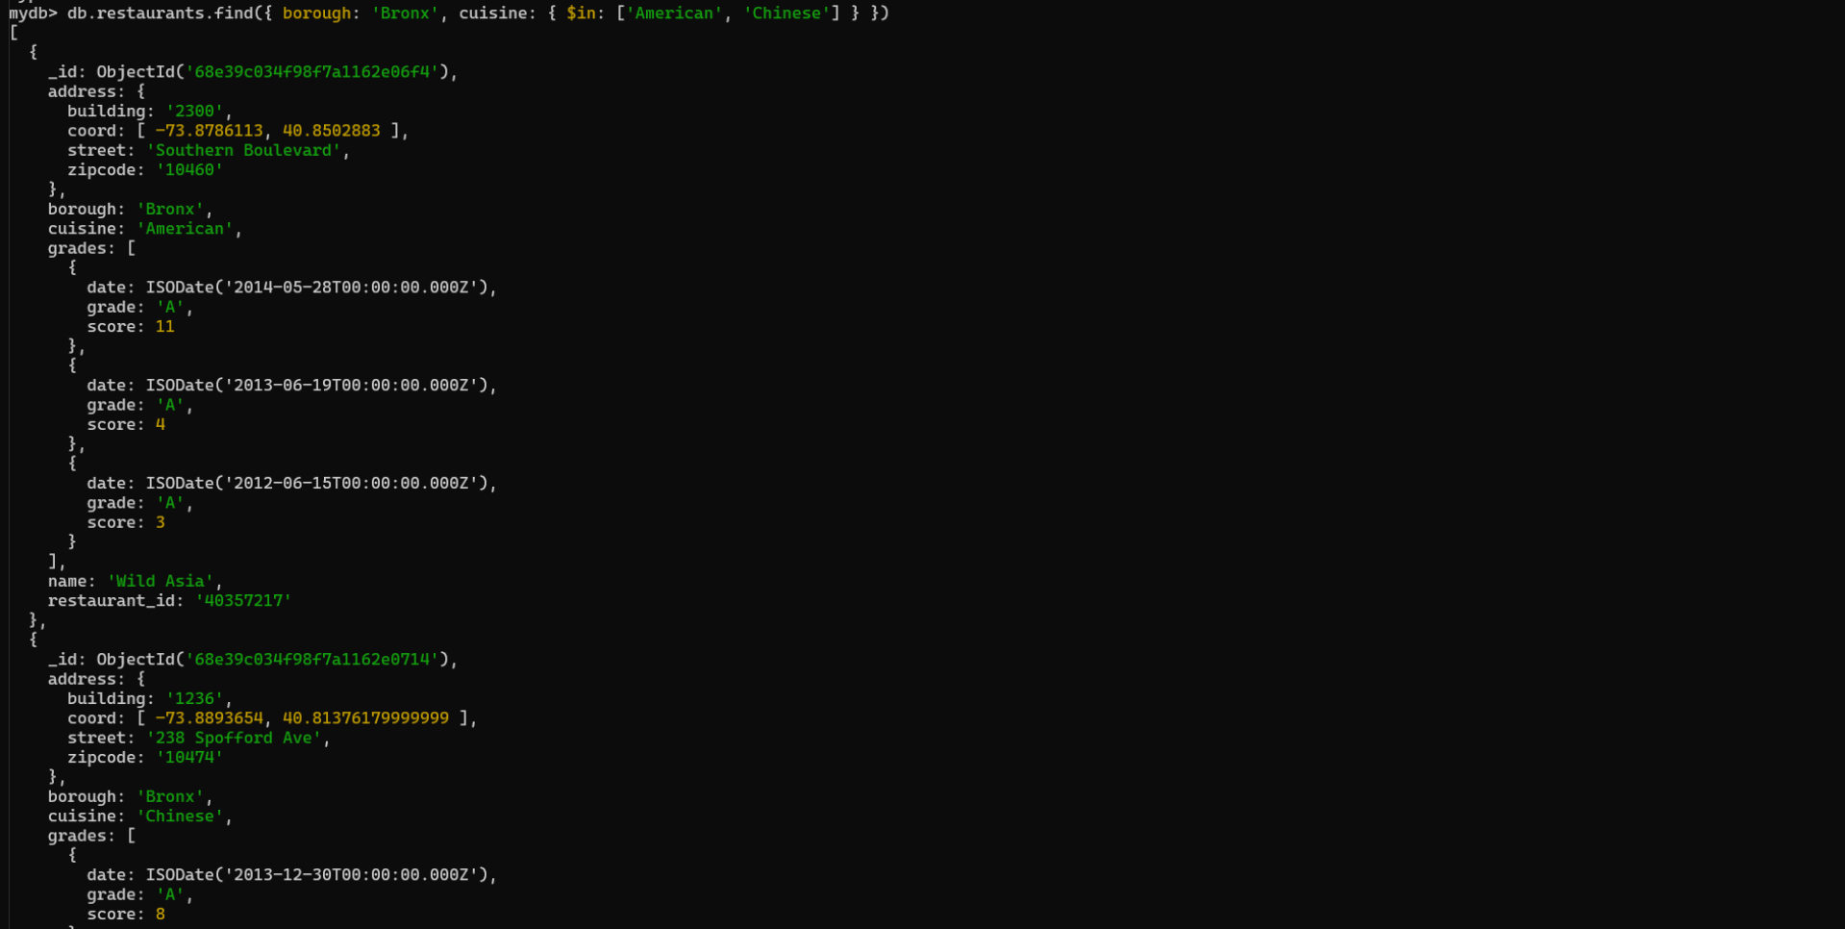
// 18. Write a MongoDB query to find the restaurant Id, name, borough and cuisine for those restaurants which belong to the borough Staten Island or Queens or Bronx or Brooklyn.
db.restaurants.find(
{ borough: { $in: ['Staten Island', 'Queens', 'Bronx', 'Brooklyn'] } },
{ restaurant_id: 1, name: 1, borough: 1, cuisine: 1, _id: 0 }
)
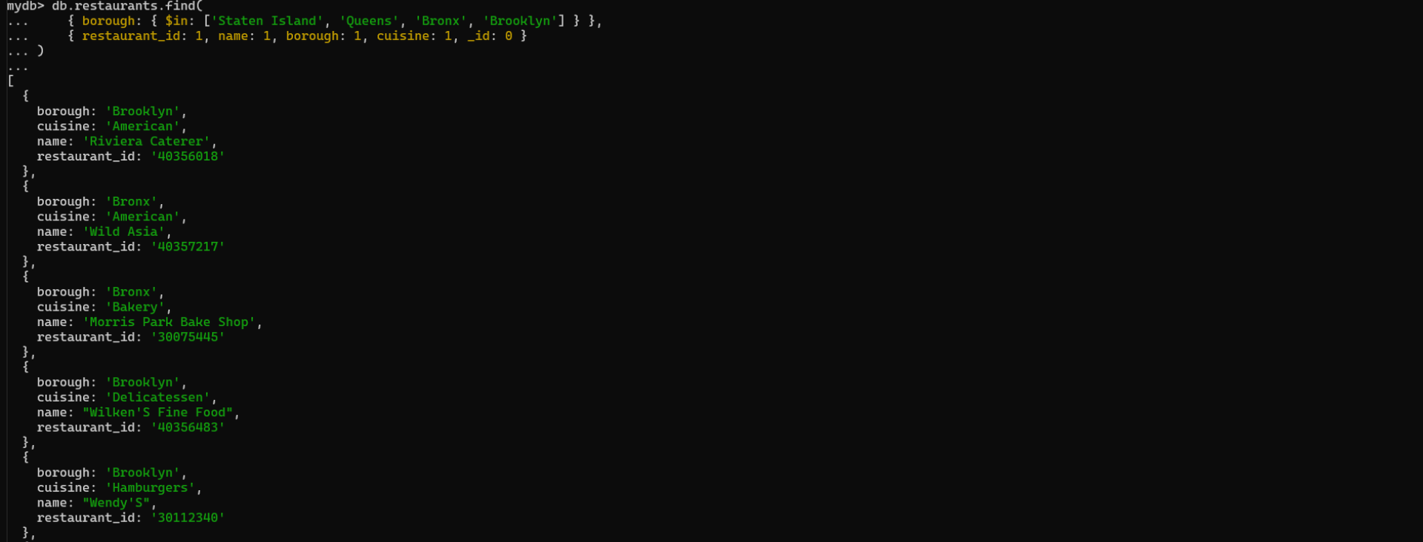
// 19. Write a MongoDB query to find the restaurant Id, name, borough and cuisine for those restaurants which are not belonging to the borough Staten Island or Queens or Bronx or Brooklyn.
db.restaurants.find(
{ borough: { $nin: ['Staten Island', 'Queens', 'Bronx', 'Brooklyn'] } },
{ restaurant_id: 1, name: 1, borough: 1, cuisine: 1, _id: 0 }
)
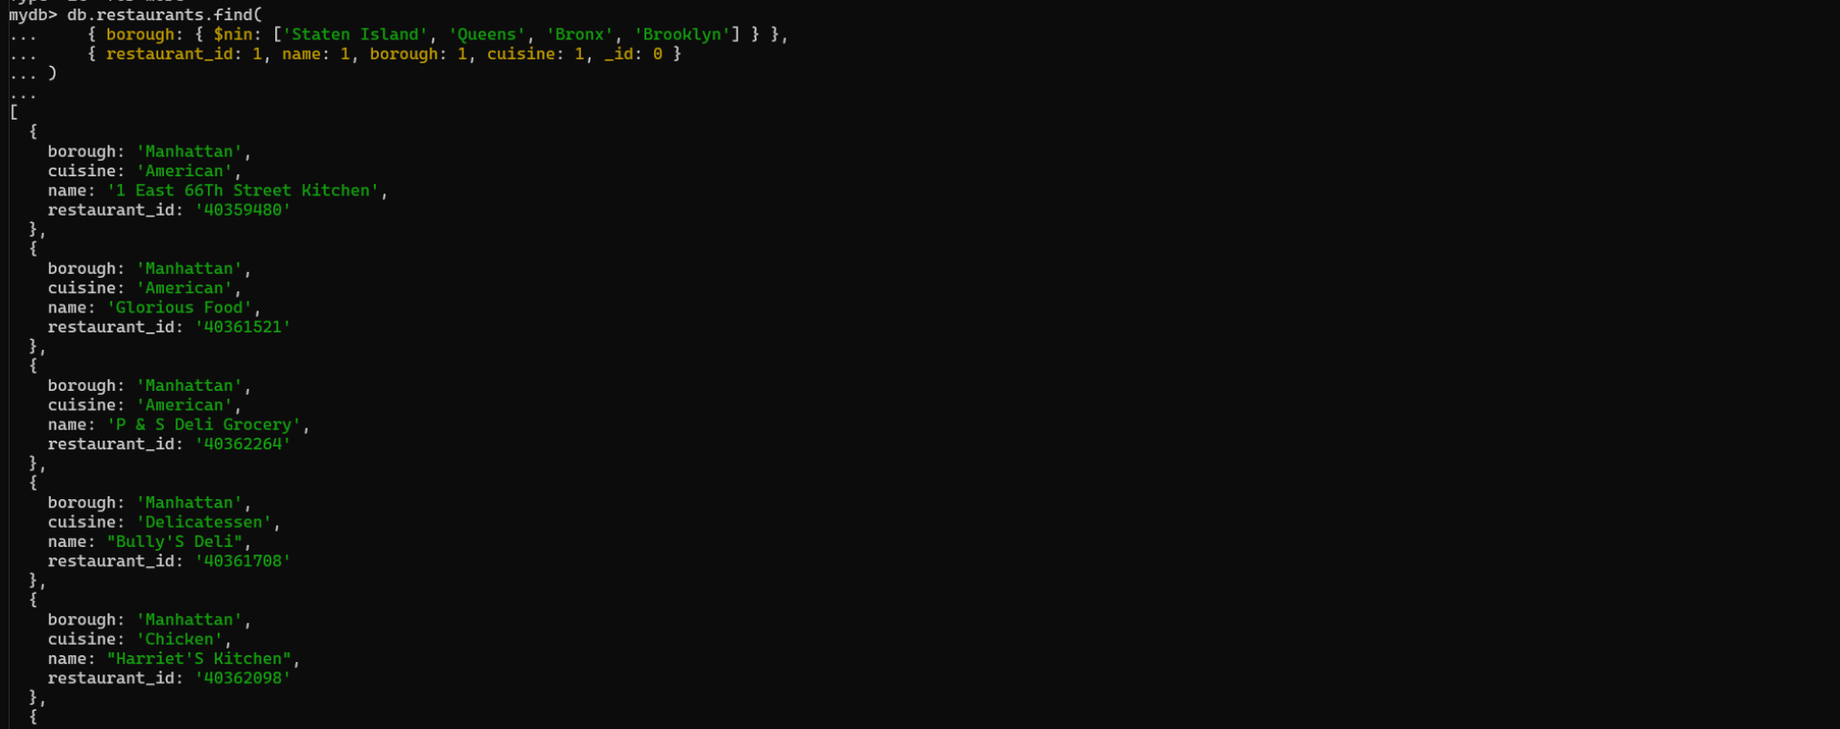

// 20. Write a MongoDB query to find the restaurant Id, name, borough and cuisine for those restaurants which achieved a score which is not more than 10.
db.restaurants.find(
{ 'grades.score': { $lte: 10 } },
{ restaurant_id: 1, name: 1, borough: 1, cuisine: 1, _id: 0 }
)
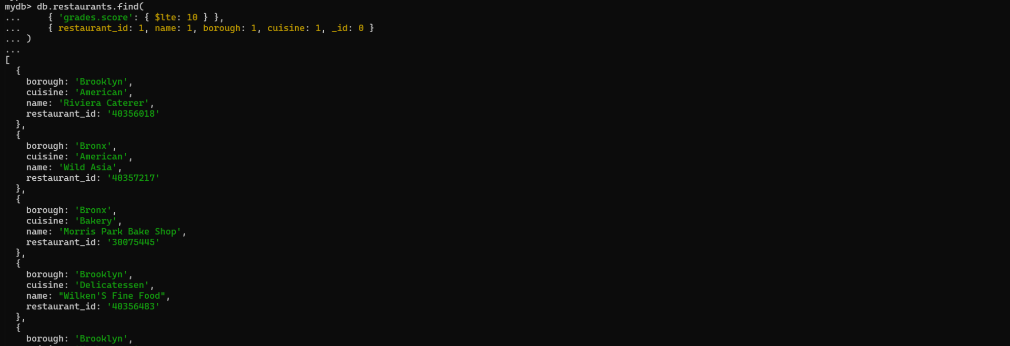

// 21. Write a MongoDB query to find the restaurant Id, name, borough and cuisine for those restaurants which prepared dish except 'American' and 'Chinees' or restaurant's name begins with letter 'Wil'.
db.restaurants.find(
{
$or: [
{ cuisine: { $nin: ['American', 'Chinees'] } },
{ name: { $regex: '^Wil', $options: 'i' } }
]
},
{ restaurant_id: 1, name: 1, borough: 1, cuisine: 1, _id: 0 }
)
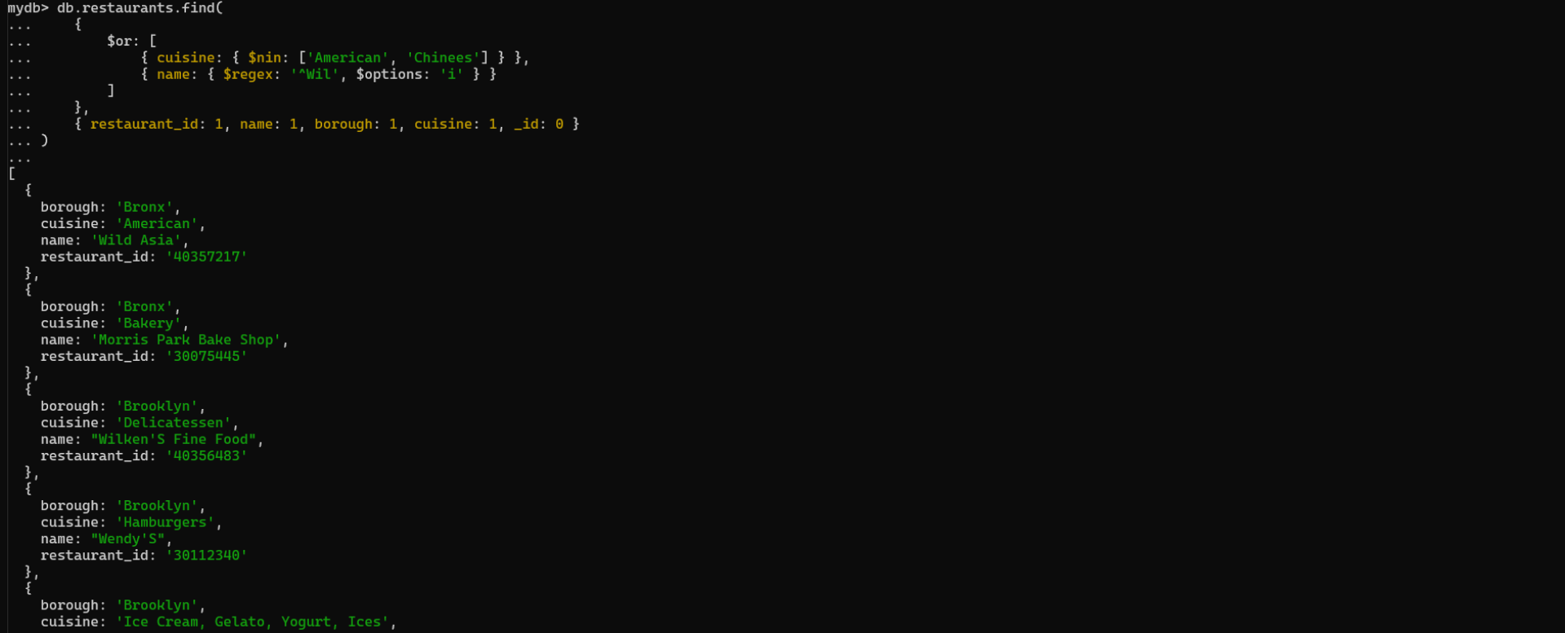
// 22. Write a MongoDB query to find the restaurant Id, name, and grades for those restaurants which achieved a grade of "A" and scored 11 on an ISODate "2014-08-11T00:00:00Z" among many of survey dates
db.restaurants.find(
{ grades: { $elemMatch: { grade: 'A', score: 11, date: ISODate('2014-08-11T00:00:00Z') } } },
{ restaurant_id: 1, name: 1, grades: 1, _id: 0 }
)
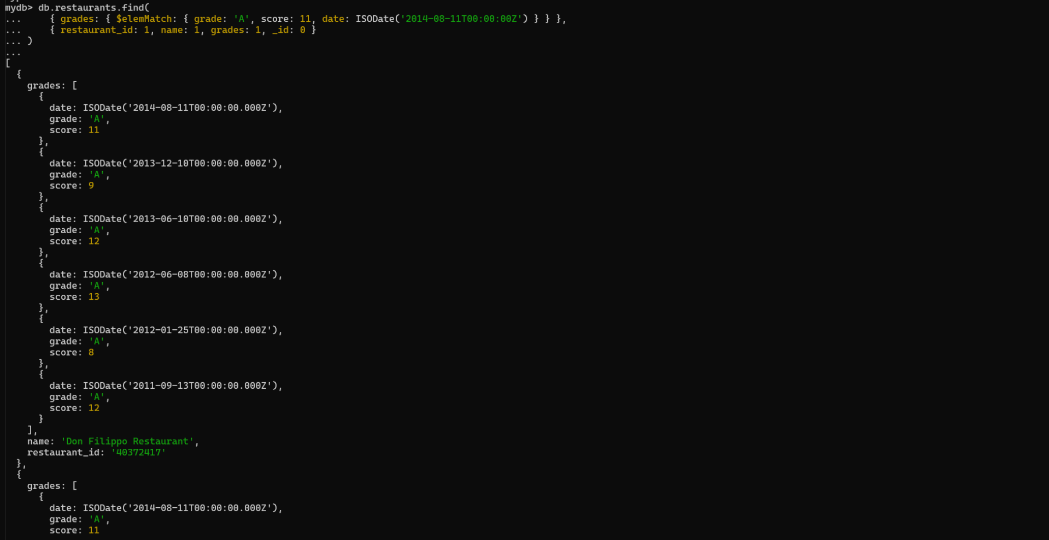
// 23. Write a MongoDB query to find the restaurant Id, name and grades for those restaurants where the 2nd element of grades array contains a grade of "A" and score 9 on an ISODate "2014-08-11T00:00:00Z".
db.restaurants.find(
{ 'grades.1.grade': 'A', 'grades.1.score': 9, 'grades.1.date': ISODate('2014-08-11T00:00:00Z') },
{ restaurant_id: 1, name: 1, grades: 1, _id: 0 }
)
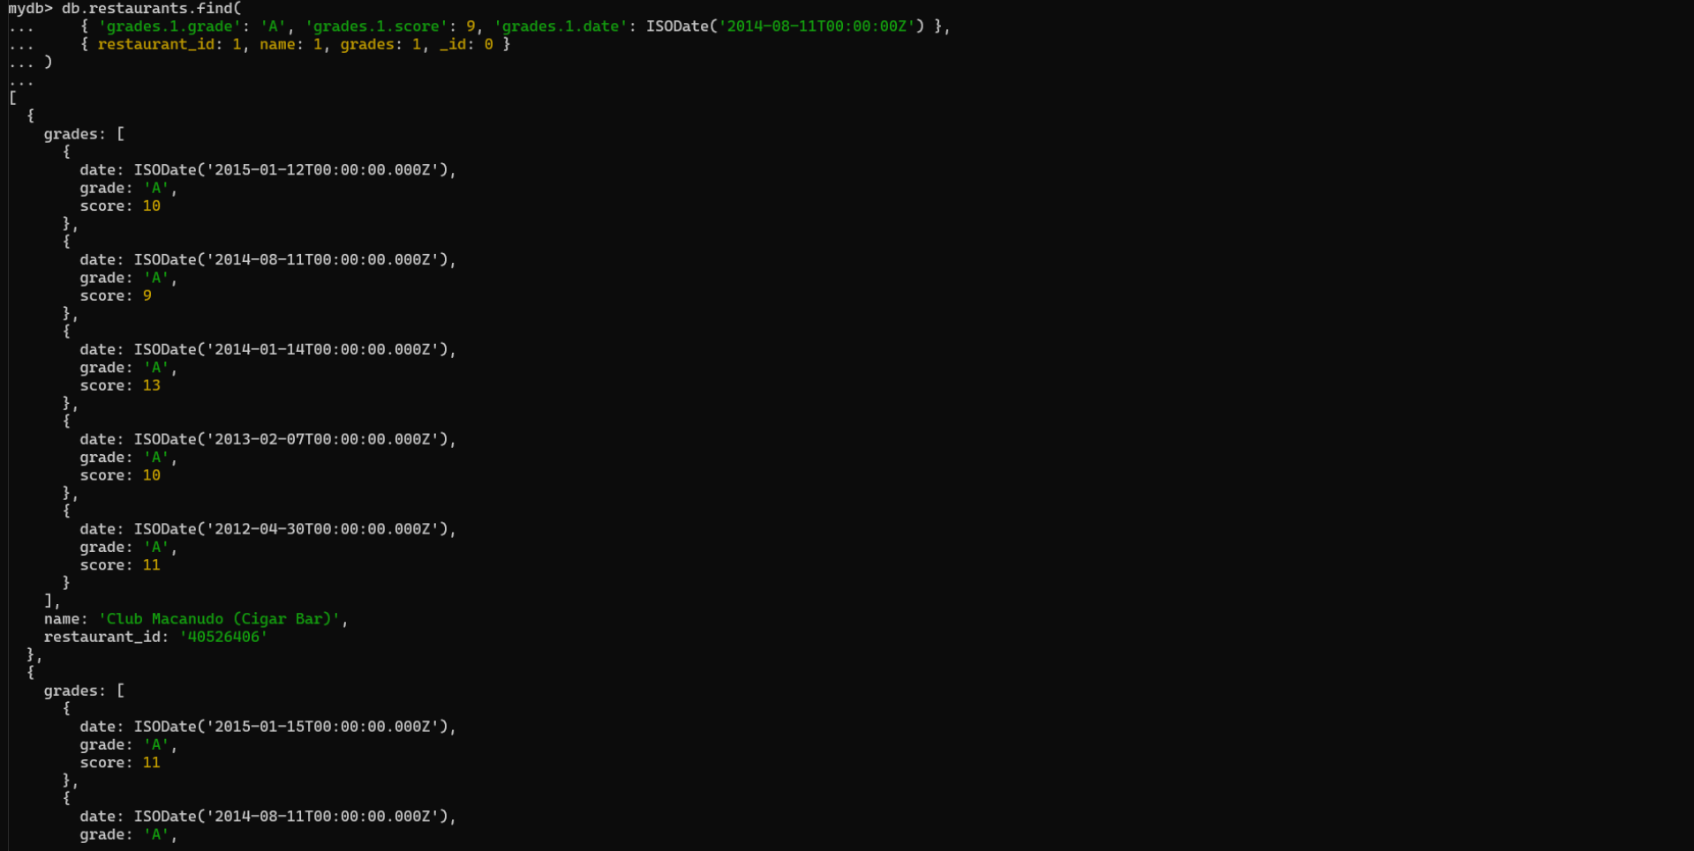
// 24. Write a MongoDB query to find the restaurant Id, name, address and geographical location for those restaurants where 2nd element of coord array contains a value which is more than 42 and upto 52
db.restaurants.find(
{ 'address.coord.1': { $gt: 42, $lte: 52 } },
{ restaurant_id: 1, name: 1, 'address.coord': 1, _id: 0 }
)

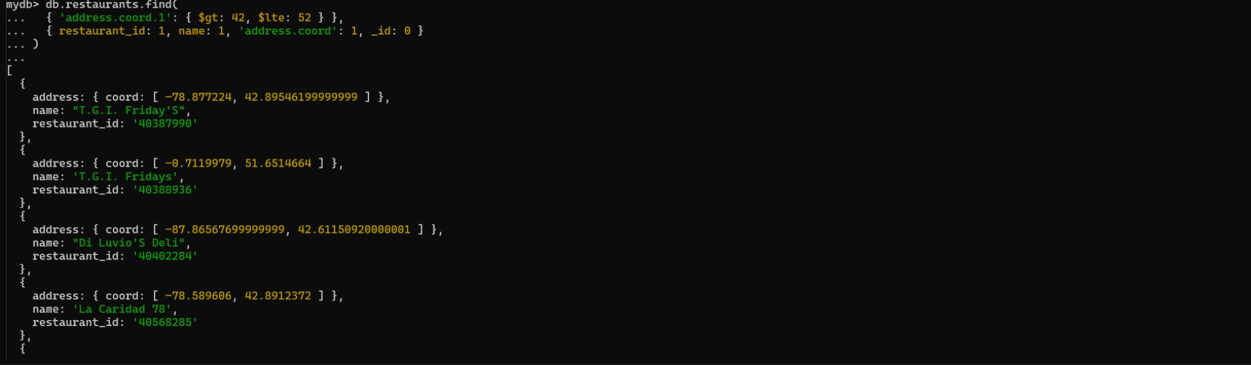
// 25. Write a MongoDB query to arrange the name of the restaurants in ascending order along with all the columns.
db.restaurants.find().sort({ name: 1 })
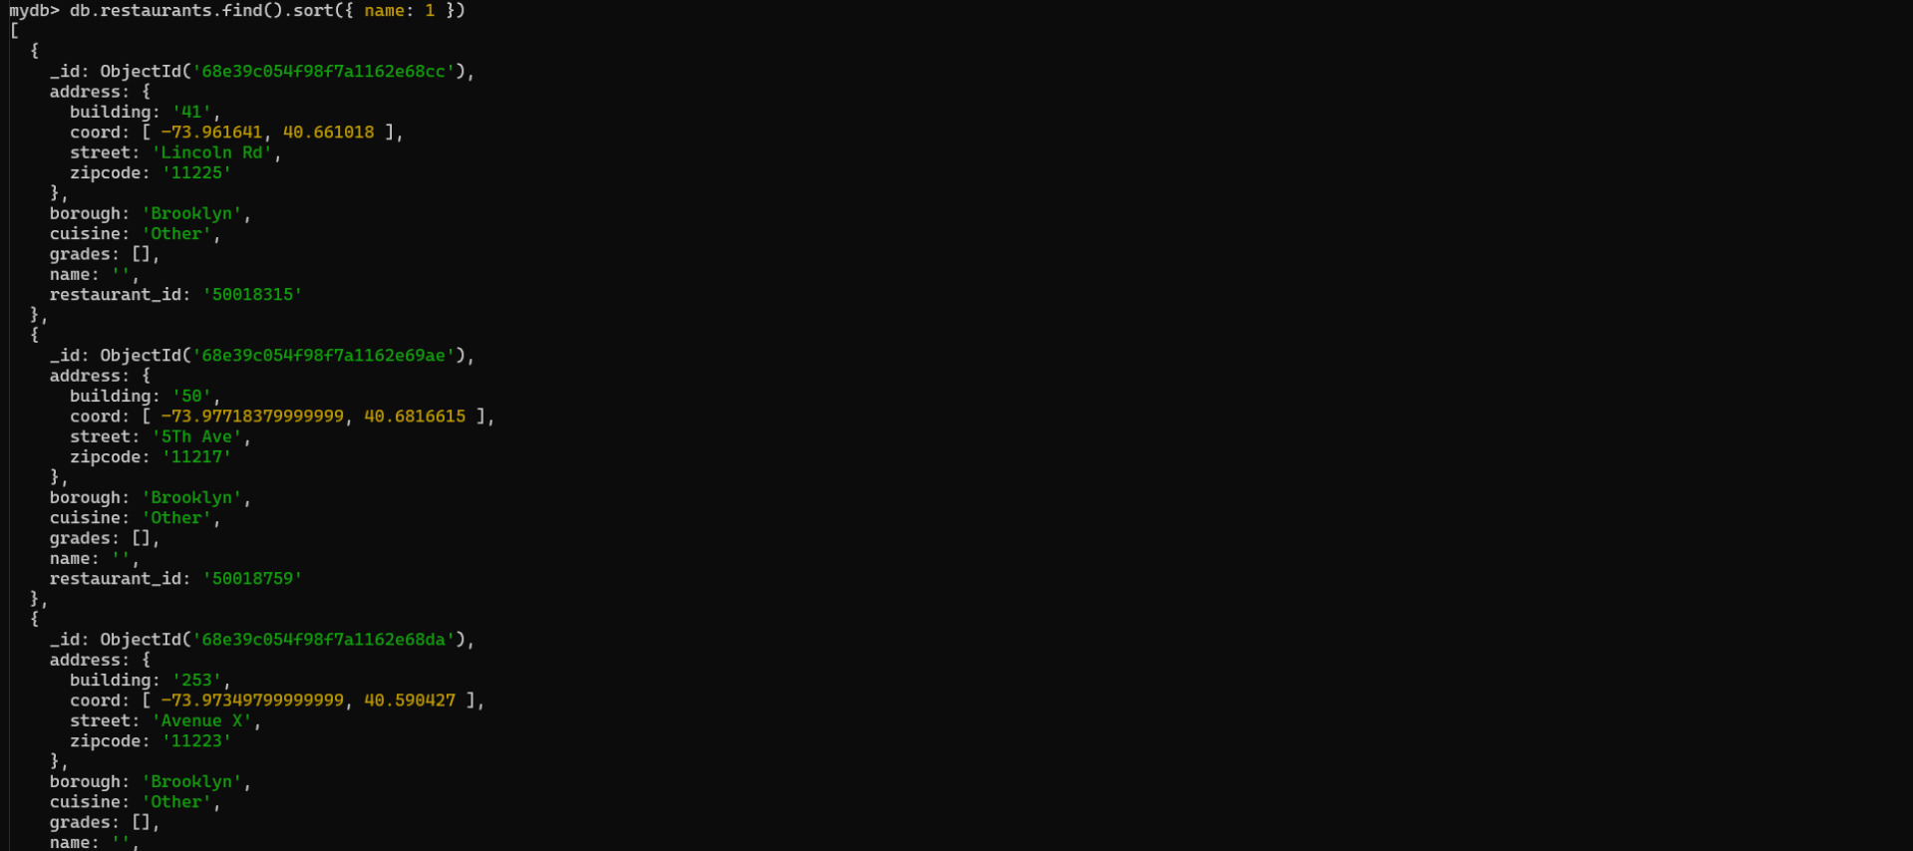
// 26. Write a MongoDB query to arrange the name of the restaurants in descending along with all the columns.
db.restaurants.find().sort({ name: -1 })
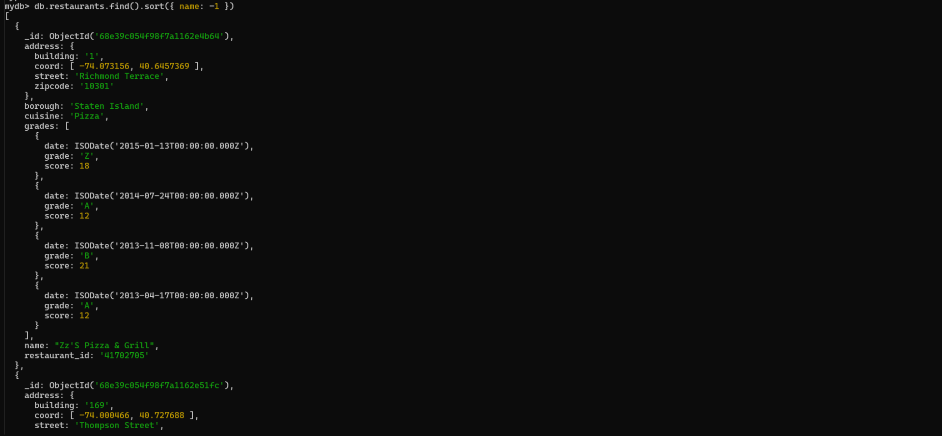
// 27. Write a MongoDB query to arrange the name of the cuisine in ascending order and for that same cuisine borough should be in descending order.
db.restaurants.find().sort({ cuisine: 1, borough: -1 })
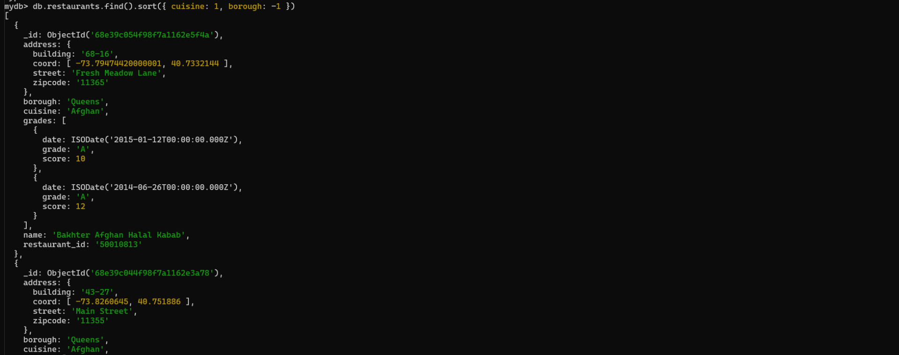
// 28. Write a MongoDB query to know whether all the addresses contains the street or not.
db.restaurants.find({ 'address.street': { $exists: false } }).count()

// 29. Write a MongoDB query which will select all documents in the restaurants collection where the coord field value is Double.
db.restaurants.find({ 'address.coord': { $type: 'double' } })
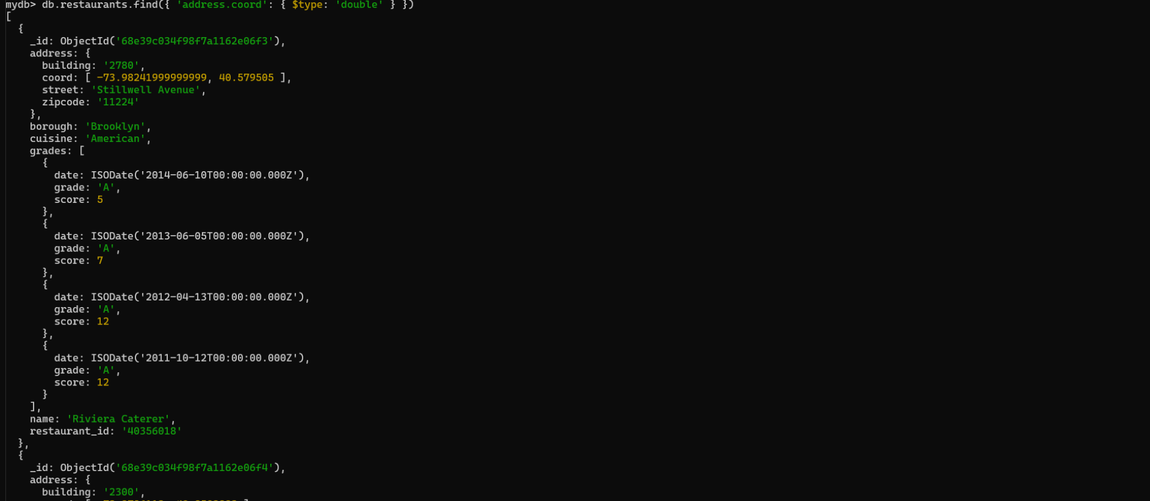
// 30. Write a MongoDB query which will select the restaurant Id, name and grades for those restaurants which returns 0 as a remainder after dividing the score by 7.
db.restaurants.find(
{ 'grades.score': { $mod: [7, 0] } },
{ restaurant_id: 1, name: 1, grades: 1, _id: 0 }
)
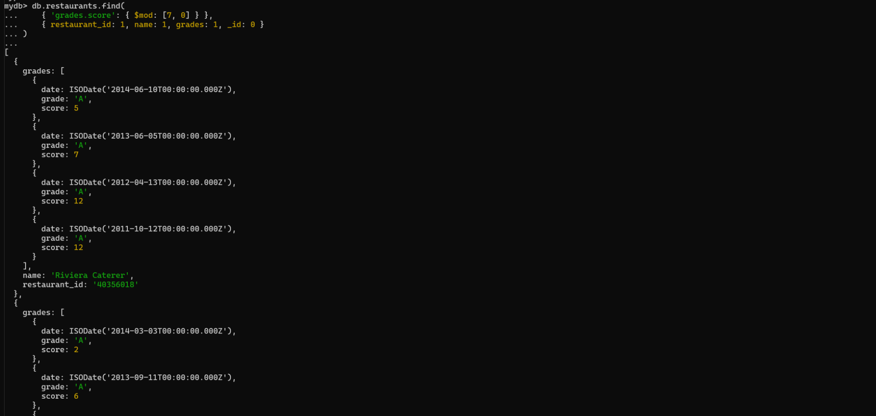
// 31. Write a MongoDB query to find the restaurant name, borough, longitude and latitude and cuisine for those restaurants which contains 'mon' as three letters somewhere in its name.
db.restaurants.find(
{ name: { $regex: 'mon', $options: 'i' } },
{ name: 1, borough: 1, 'address.coord.0': 1, 'address.coord.1': 1, cuisine: 1, _id: 0 }
)
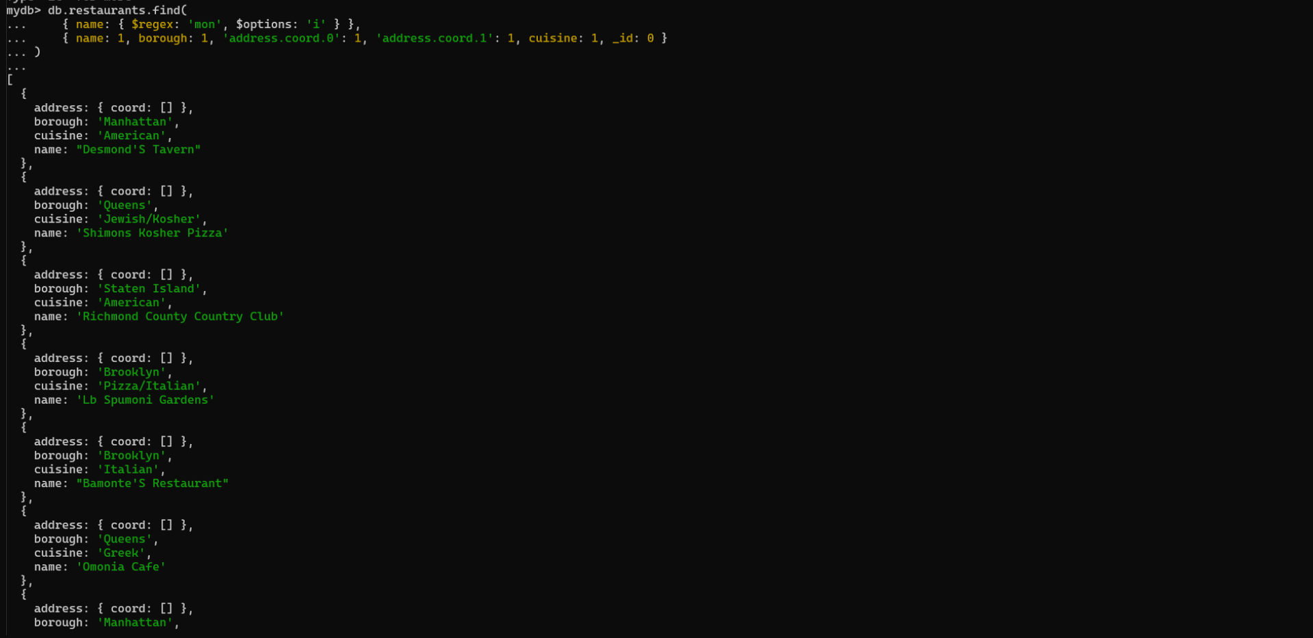
// 32. Write a MongoDB query to find the restaurant name, borough, longitude and latitude and cuisine for those restaurants which contain 'Mad' as first three letters of its name.
db.restaurants.find(
{ name: { $regex: '^Mad', $options: 'i' } },
{ name: 1, borough: 1, 'address.coord.0': 1, 'address.coord.1': 1, cuisine: 1, _id: 0 }
)
